ICP1-SHASHANK ARVA-700756617

1. Write a python program for the following:

* Input the string “Python” as a list of characters from console, delete at least 2 characters, reverse the resultant string and print it.

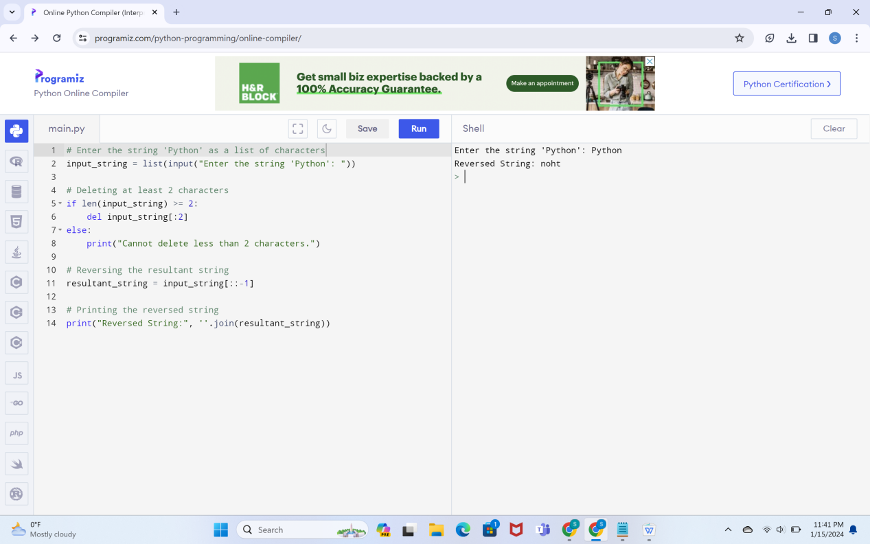

* Take two numbers from user and perform at least 4 arithmetic operations on them.

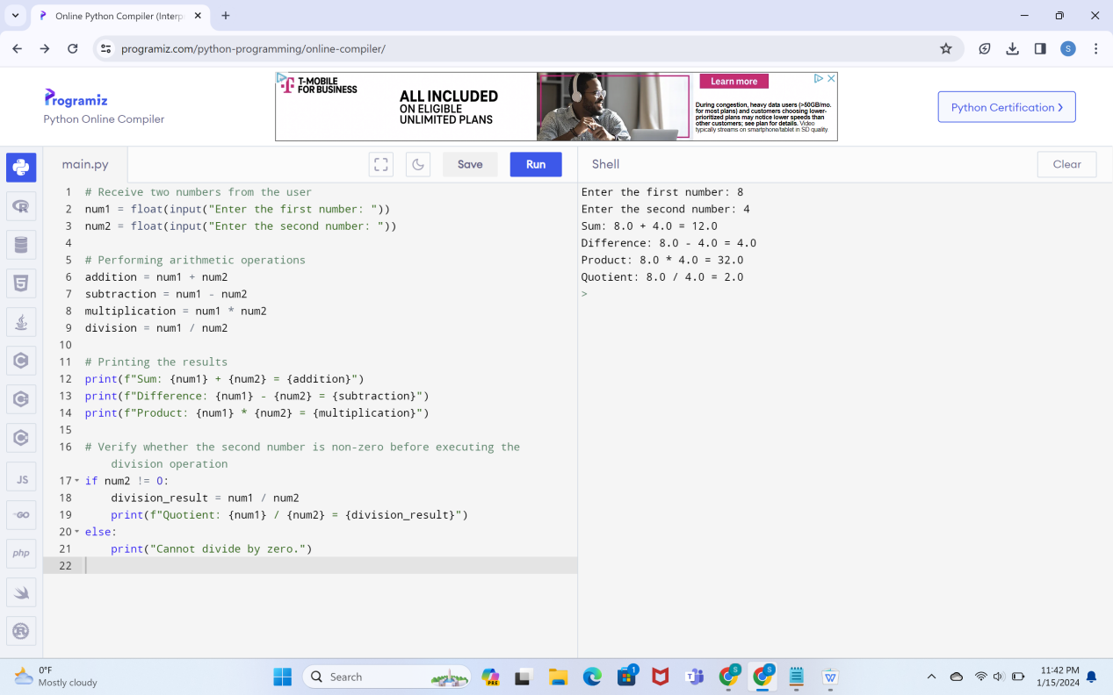

1. Write a program that accepts a sentence and replace each occurrence of ‘python’ with ‘pythons’.

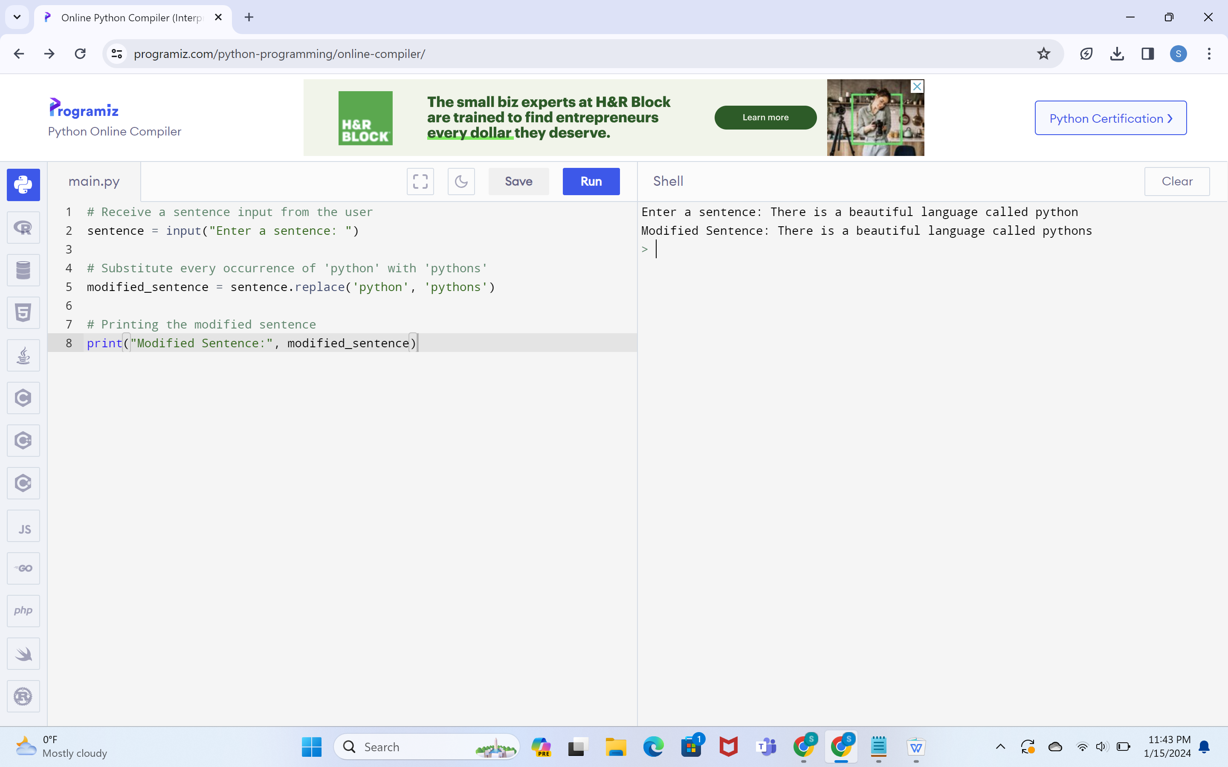

1. Use the if statement conditions to write a program to print the letter grade based on an input class score. Use the grading scheme we are using in this class.

